# Scope Udemy Url - [Notebook](https://notebook.zohopublic.in/public/notes/bietv379bff087eca47eaa84a3024d7e14b46)

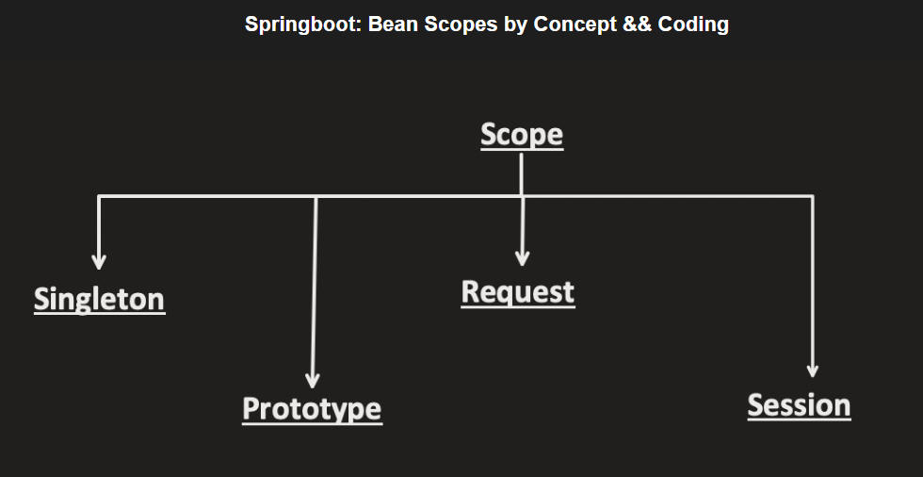

And 5. Application/global session scope

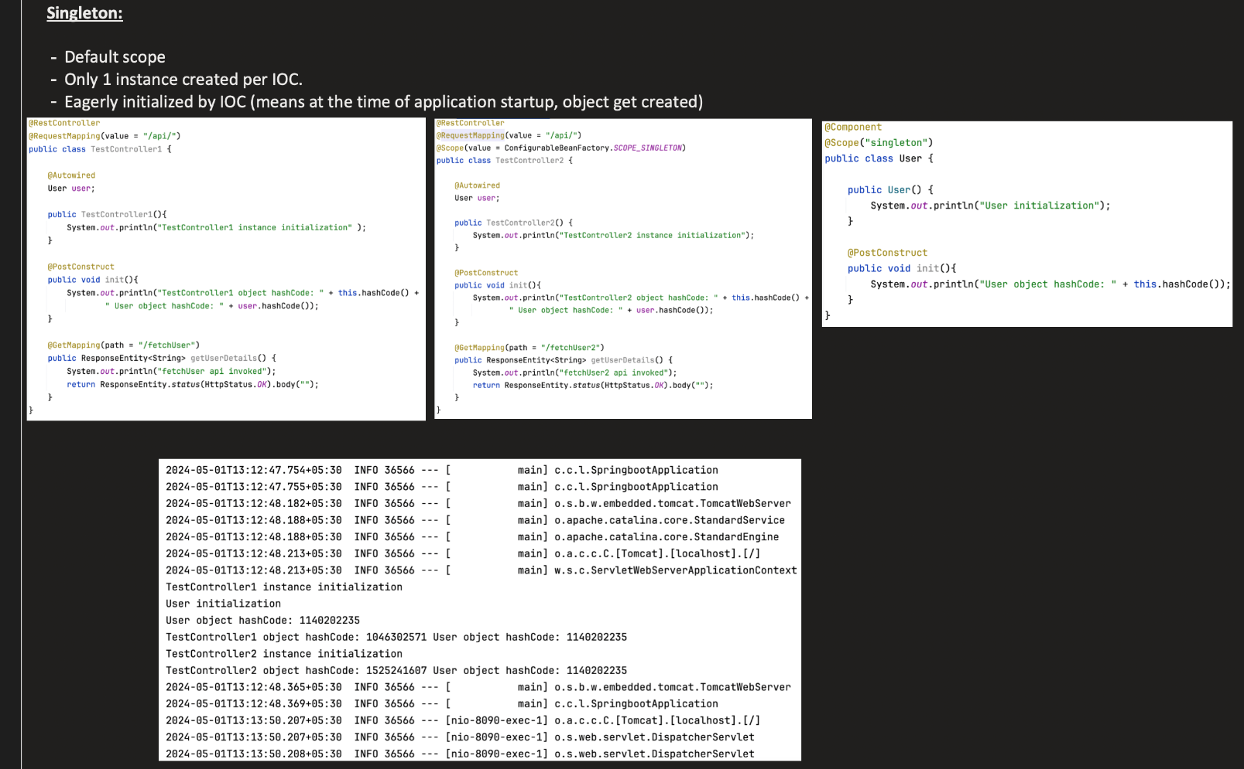

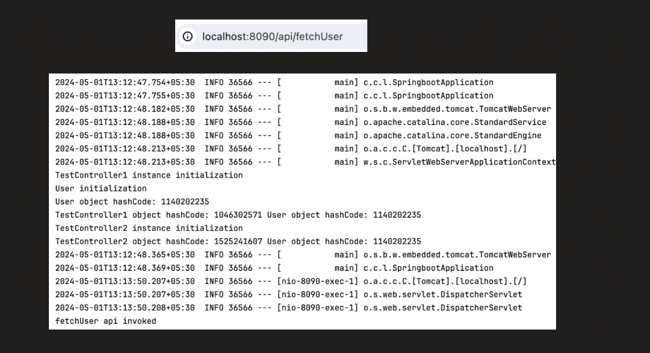

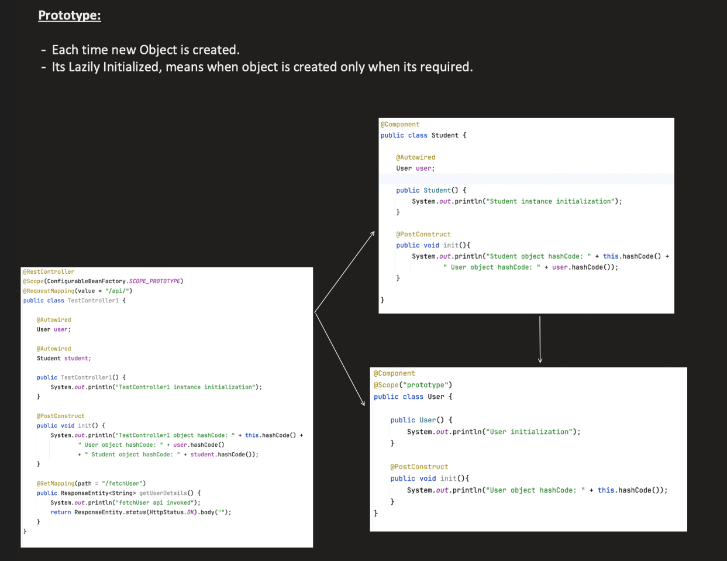

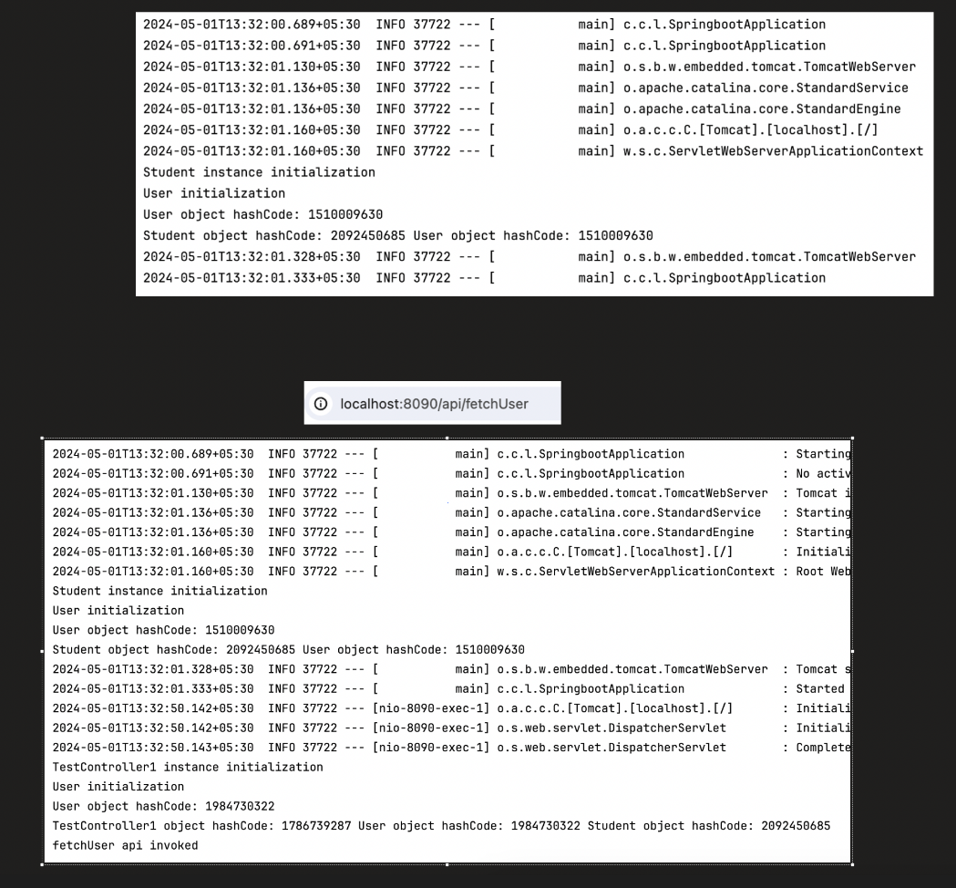

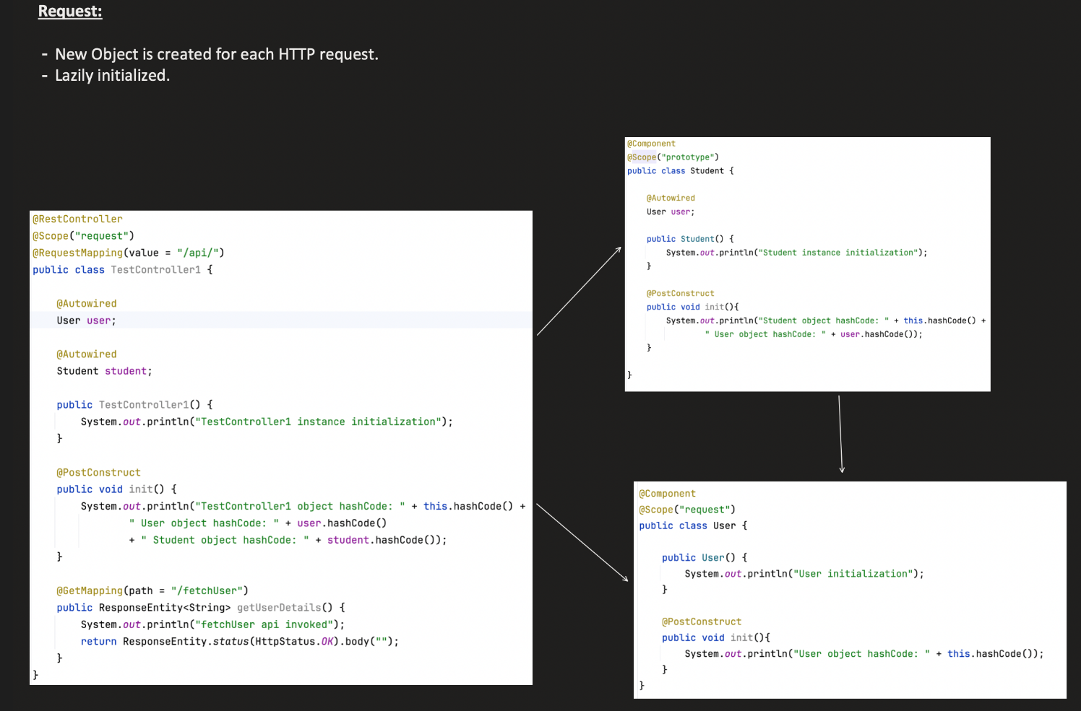

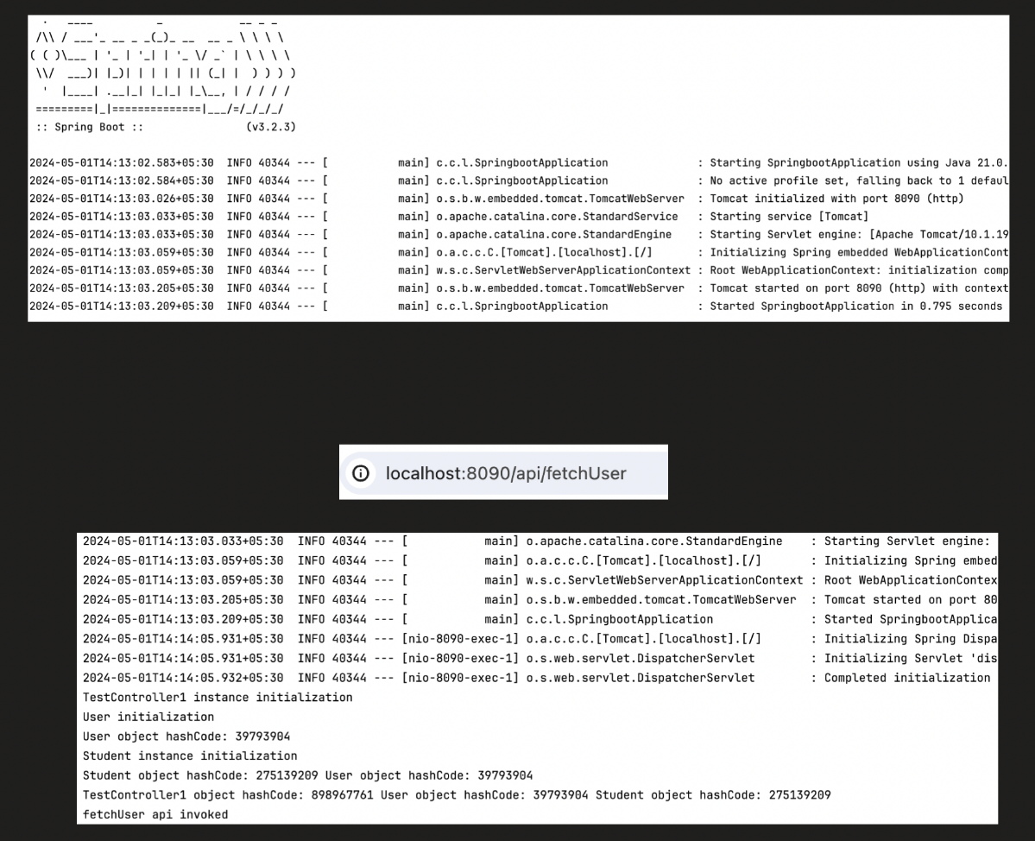

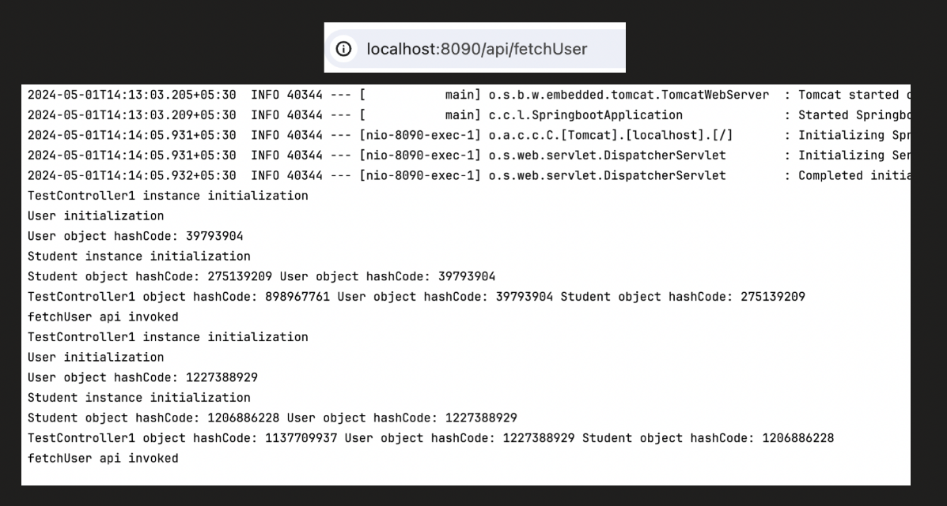

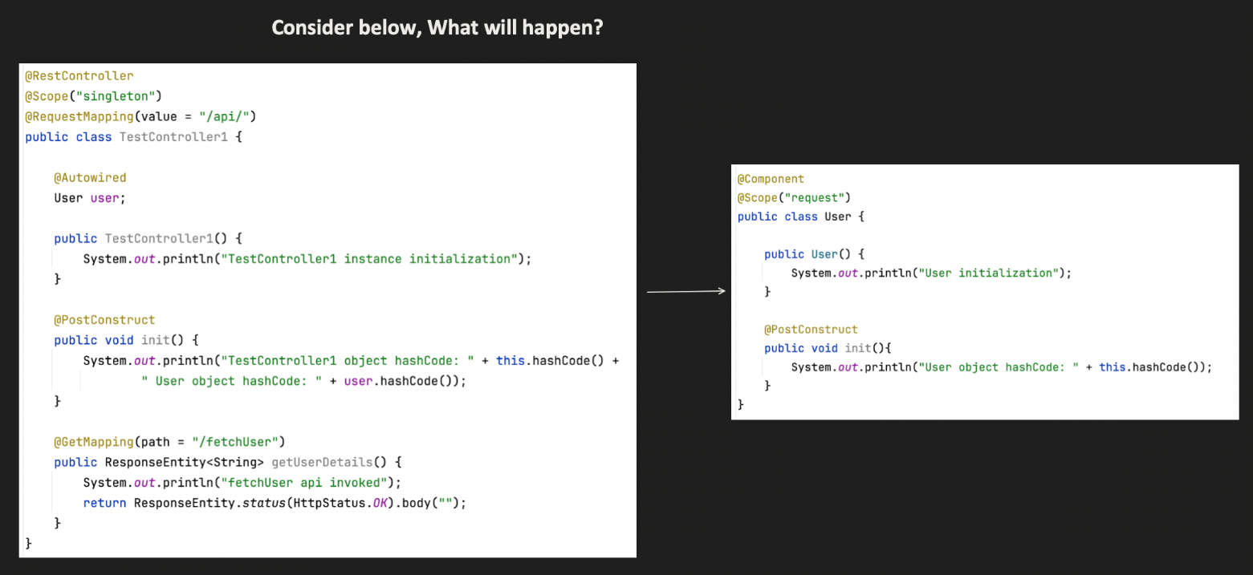

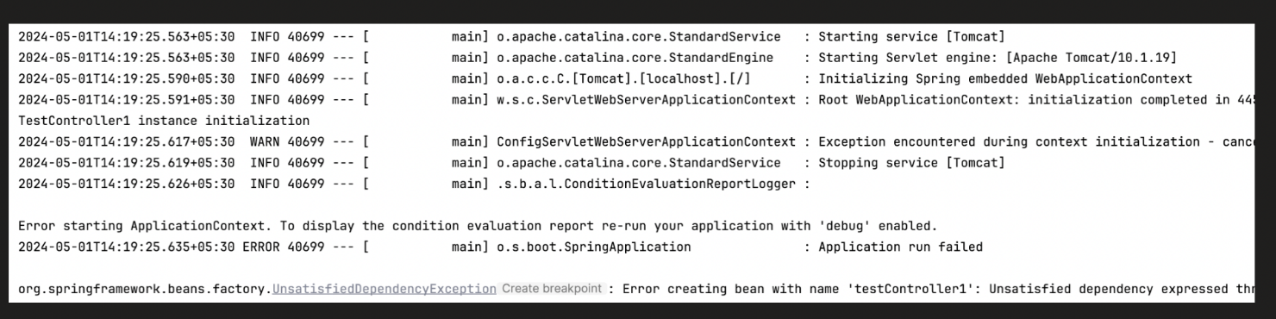

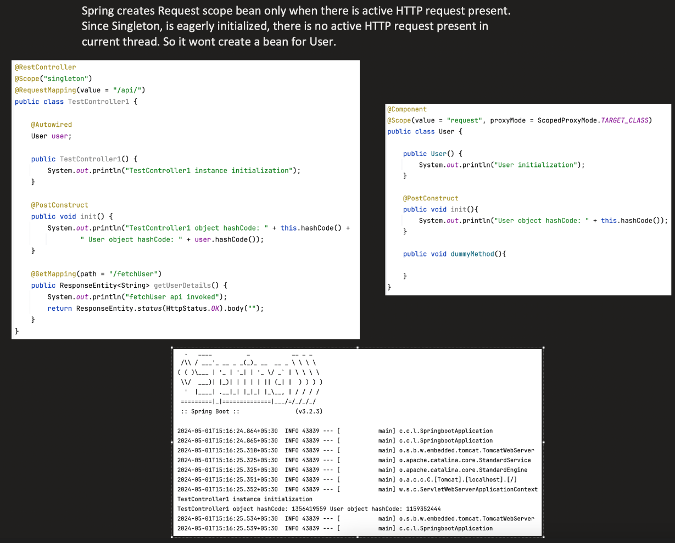

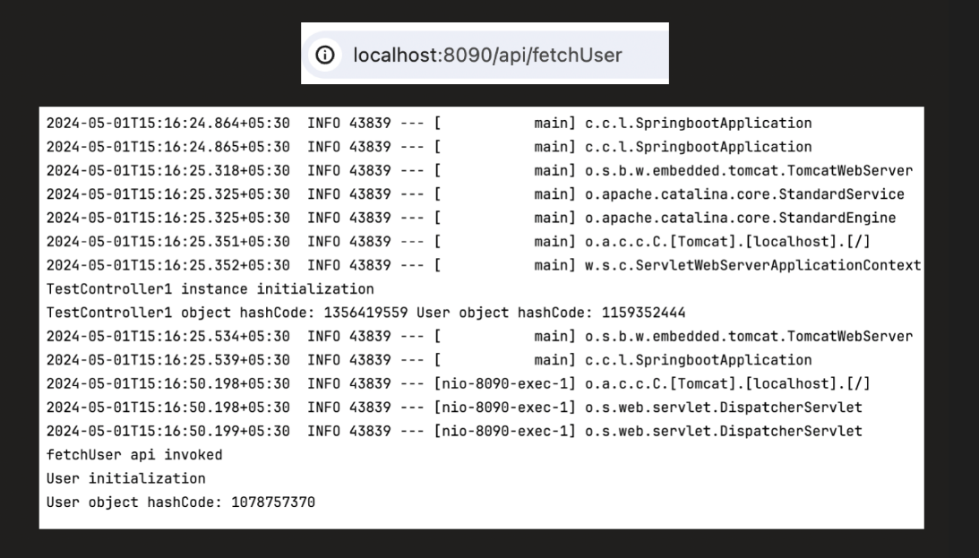

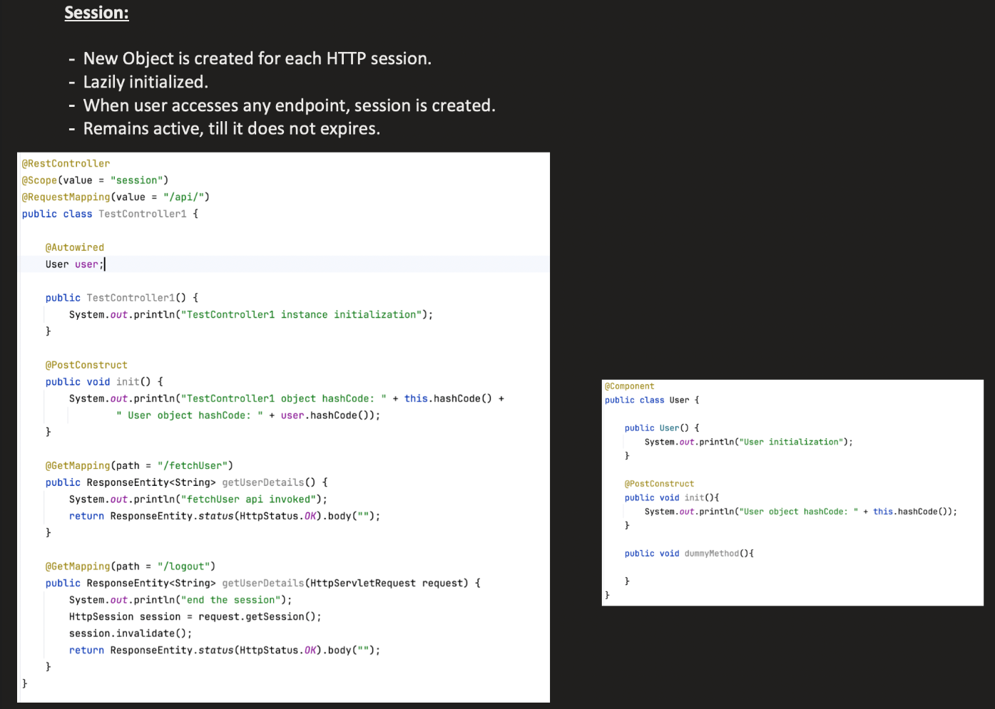

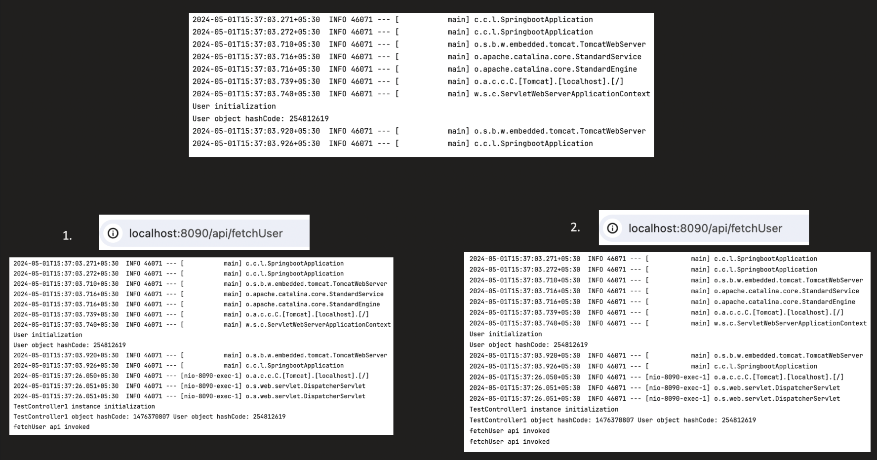

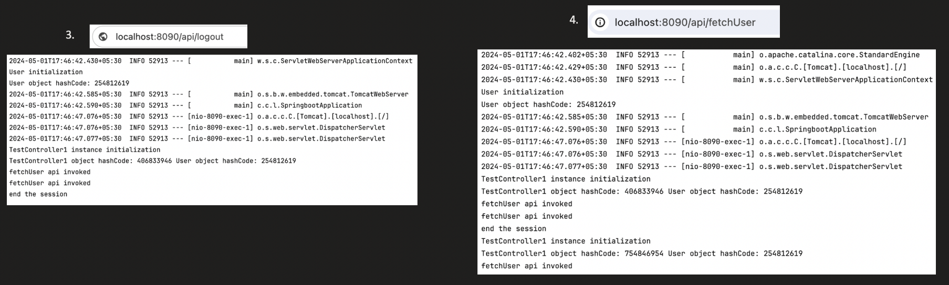

**🔵 5.** Application /global session scope – eagerly, created once and shared among multiple IOCs.

* One instance per **ServletContext** (i.e., global to the application).

@Component

@Scope(value = WebApplicationContext.SCOPE_APPLICATION)

public class MyAppBean { }

🧠 **Use when:** Shared global data is needed across the entire application (rarely used).

**🔵 6. websocket**

* One instance per **WebSocket session**.

@Component

@Scope(value = "websocket")

public class MyWebSocketBean { }

🧠 **Use when:** Working with WebSocket communication (chat apps, live notifications, etc.)

❓ **What happens when a singleton bean depends on a prototype bean?**

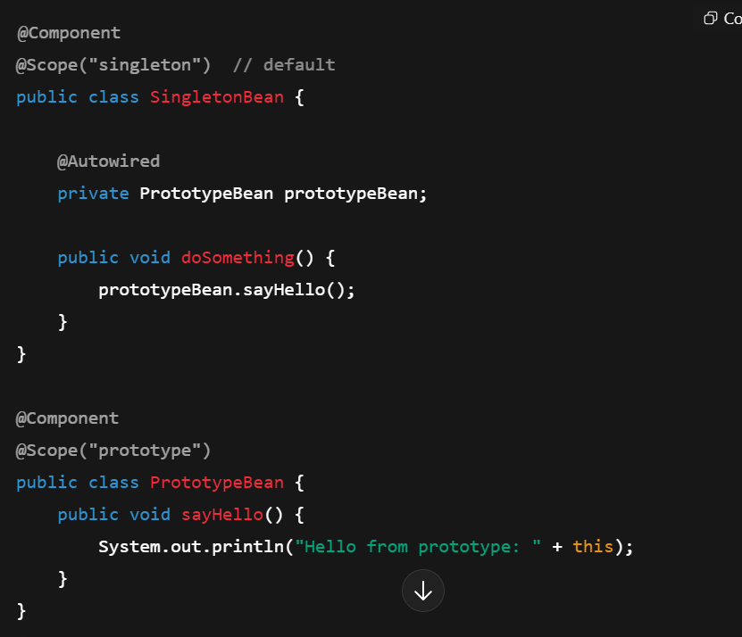

**🔴 Problem: Singleton "locks in" the prototype**

* SingletonBean is created **only once**.
* At that time, Spring injects an instance of PrototypeBean.
* That same instance is reused **every time** SingletonBean is used.

**⛔ So even though PrototypeBean is prototype-scoped, it behaves like a singleton inside SingletonBean.**

Use Scoped Proxy (@Scope(..., proxyMode = ...)) — only if you want to inject a proxy

⚠️ But **be careful**: the proxy only works correctly if the bean is **used in a stateless, short-lived way**.  
You must not **store it as a field or cache** the result of method calls.

# Dynamically Initialized Beans / @Value annotation Udemy Url - [Notebook](https://notebook.zohopublic.in/public/notes/bietv13e5f5aeff684305a86e2d251aa4deed)

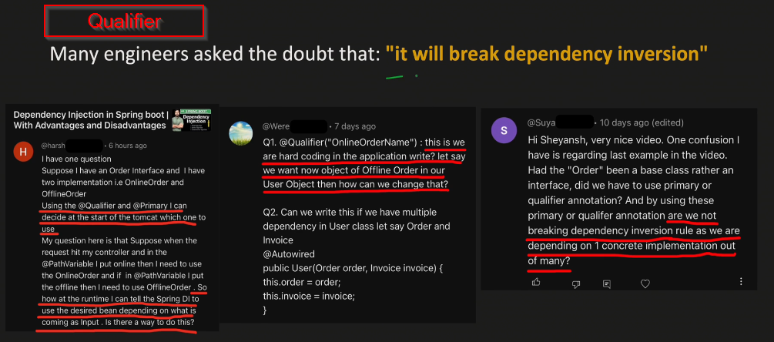

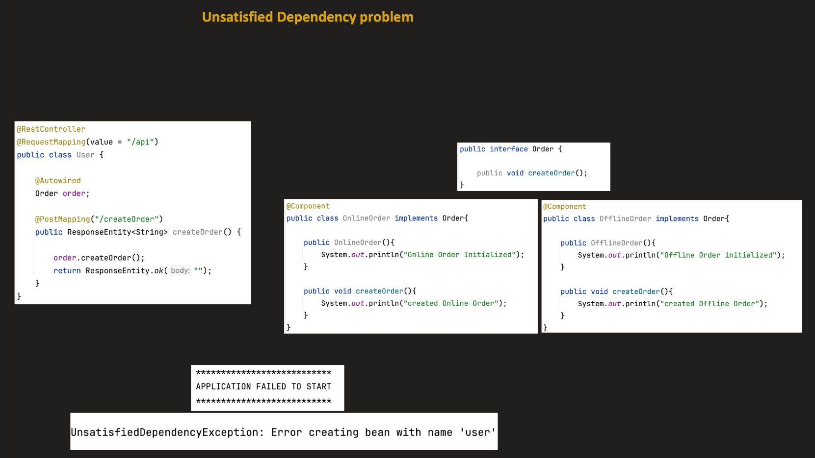

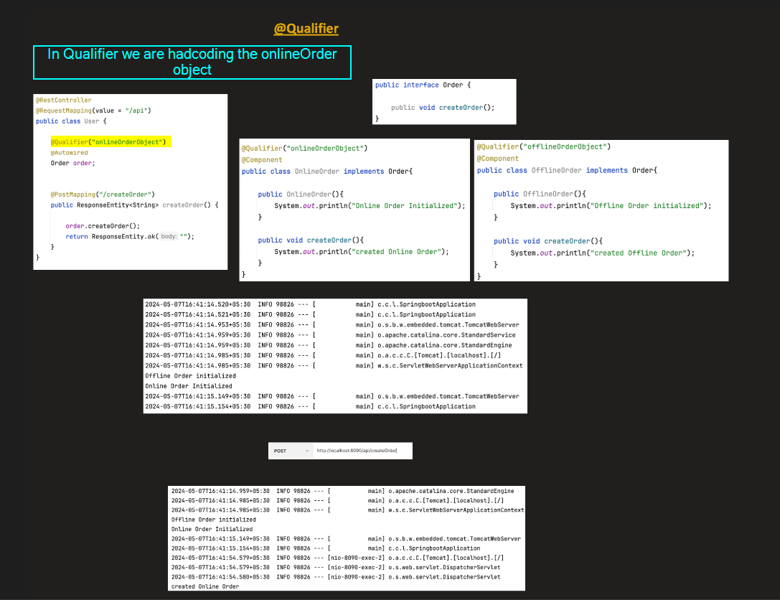

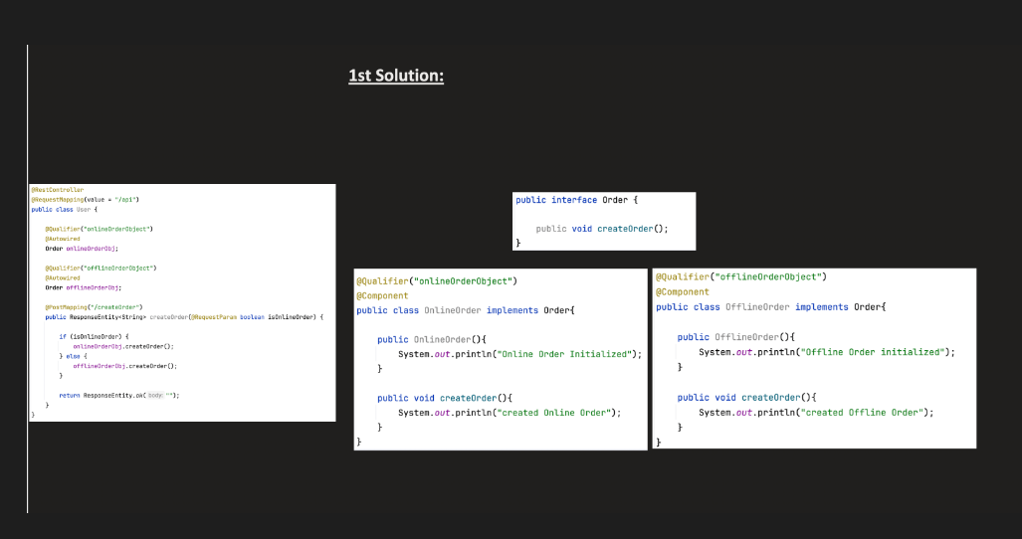

1st solution followed in industry.

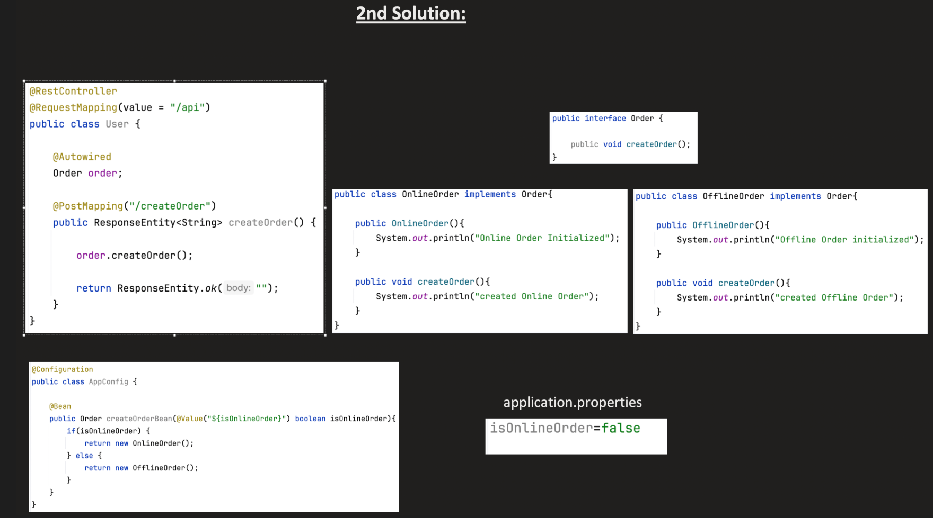

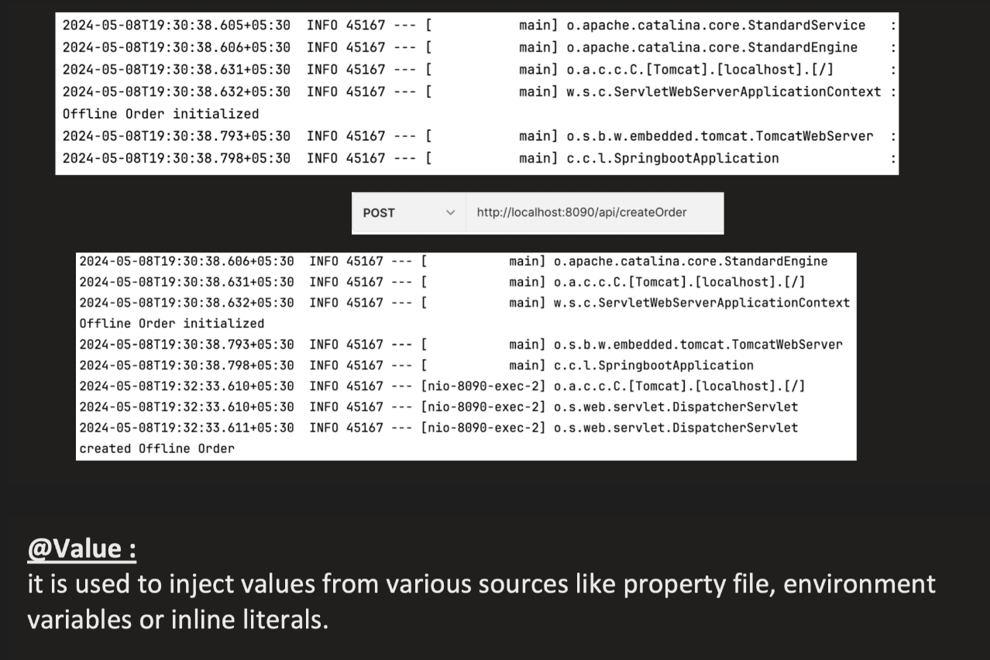

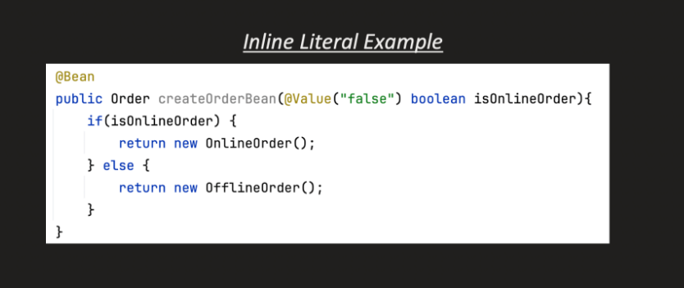

The @Value annotation in Spring is used to **inject values into fields, method parameters, or constructor arguments** from:

* properties files (application.properties, application.yml)
* environment variables
* system properties
* Spring Expression Language (SpEL) expressions
* literal values

## ✅ **Basic Usage**

### Injecting a literal:

@Value("Hello Spring!")

private String message;

**Injecting from application.properties:**

app.name=RedBus

app.timeout=5000

@Value("${app.name}")

private String appName;

@Value("${app.timeout}")

private int timeout;

**Using default value:**

@Value("${app.version:1.0.0}")

private String appVersion;

If app.version is not found, it uses "1.0.0" as the default.

**🧠 Advanced Usages**

**SpEL (Spring Expression Language):**

@Value("#{2 * 2}")

private int result; // 4

@Value("#{T(java.lang.Math).random() * 100}")

private double randomValue;

@Value("#{someBean.someProperty}")

private String valueFromOtherBean;

**Injecting a List or Array from comma-separated value:**

properties

app.servers=server1,server2,server3

@Value("#{'${app.servers}'.split(',')}")

private List<String> servers;

**Injecting environment variable:**

@Value("${JAVA_HOME}")

private String javaHome;

Make sure environment variable is exposed to the app.

